EXPERIMENT 5

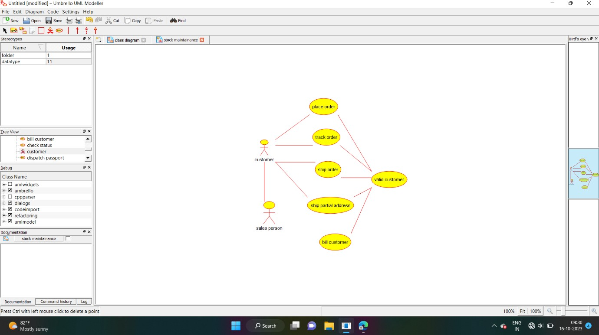

USE CASE DIAGRAM

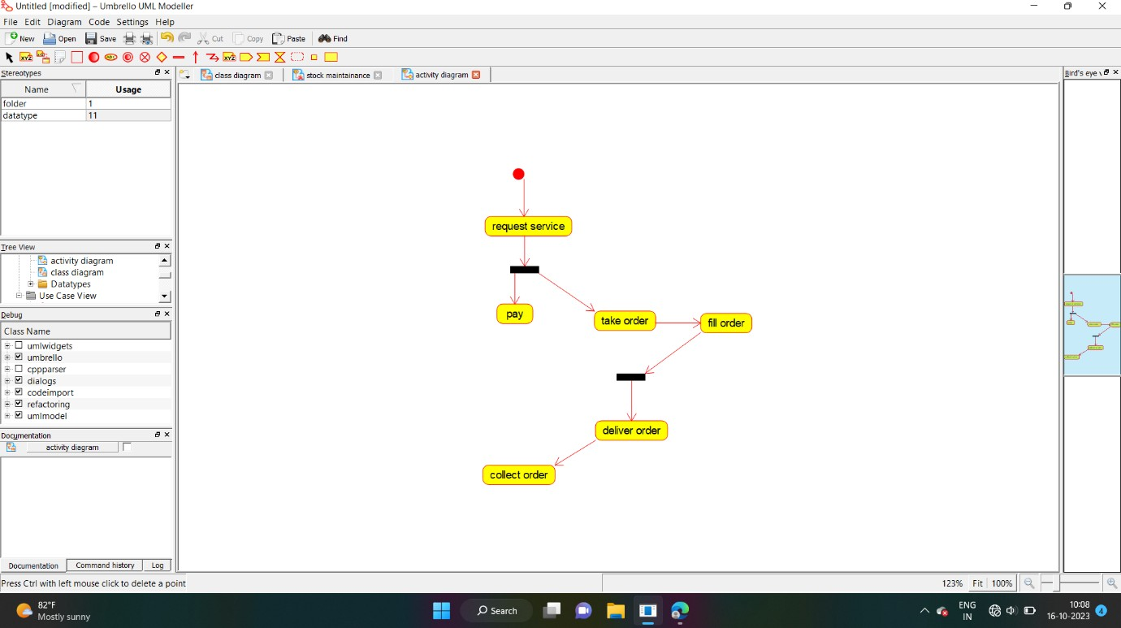

ACTIVITY DIAGRAM

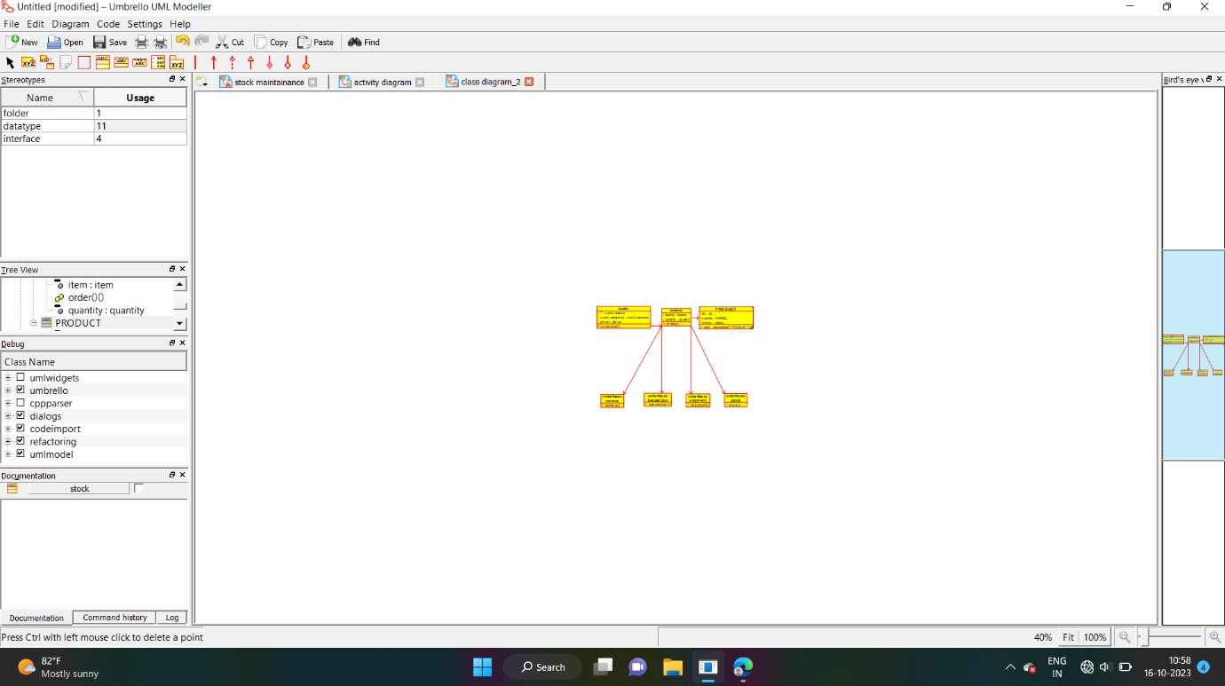

CLASS DIAGRAM

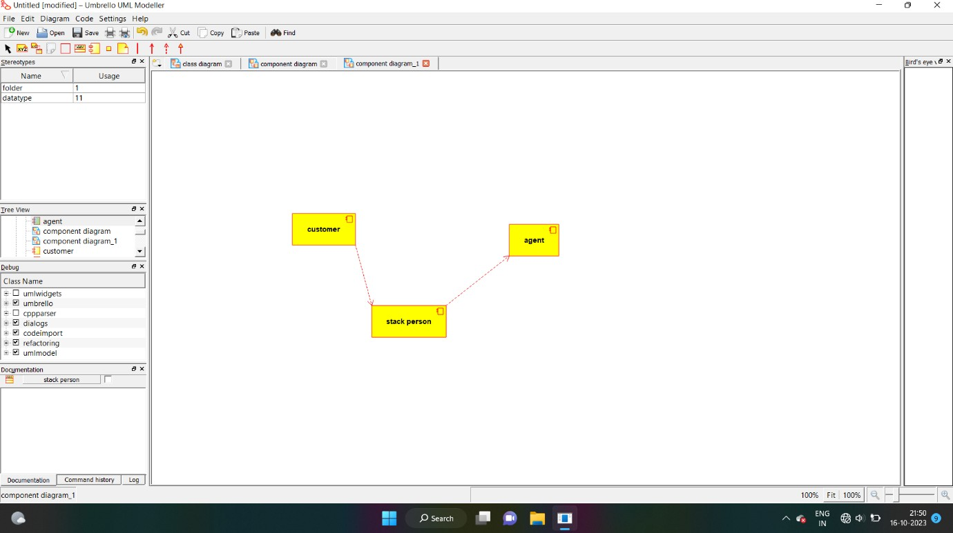

COMPONENT DIAGRAM

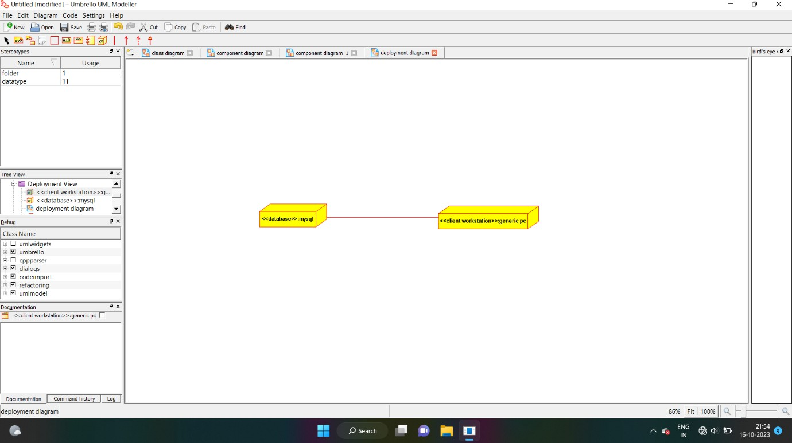

DEPLOYMENT DIAGRAM